Planetary Orbits and Kepler’s Laws

Introduction
At first I believed I was dreaming... But it is absolutely certain and exact that the ratio which exists between the period times of any two planets is precisely the ratio of the 3/2th power of the mean distance.
— translated from Harmonies of the World by Kepler (1619)
The 16th century Danish astronomer Tycho Brahe and his team made the most accurate catalog of stellar and planetary positions in the ages prior to the invention of the telescope. Based on Tycho Brahe’s work, his German assistant Johannes Kepler deduced three laws of planetary motion around 1610. The entire catalog, called the Rudolphine Tables, was published in 1627.
Much later on, it was realized that these three laws were direct consequences of Sir Issac Newton’s law of universal gravitation (1687). The work of Tycho Brahe and Johannes Kepler still stands as a groundbreaking achievement in the ability to make patient and precise observations without the benefit of a telescope!

Materials needed:
- Simulations:
  - Gravity and orbits: https://phet.colorado.edu/sims/html/gravity-and-orbits/latest/gravity-and-orbits_en.html
  - Kepler’s second law: https://www.walter-fendt.de/html5/phen/keplerlaw2_en.htm
  - Elliptical orbits and Kepler’s second law: https://ophysics.com/f6.html
- Videos (while not recommended-these describe Kepler’s 3 Laws (Same as in module)
  - Kepler’s First Law of Motion - Elliptical Orbits (Astronomy)
  - Kepler’s Second Law of Motion (Astronomy)
  - Kepler's Third Law of Motion (Astronomy)

Part 1: Linking planetary orbits to Kepler’s Laws

Go to model: https://phet.colorado.edu/sims/html/gravity-and-orbits/latest/gravity-and-orbits_en.html
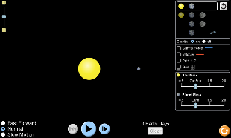

- Click on Model

- Click sun and planet
- Press PLAY, blue circle (with path/gravity/ velocity/grid ON, green circle) and leave for one cycle then PAUSE.

- What holds the planet in the orbit?
Gravity is the force that keeps planets in orbit around the Sun.

- What shape is the orbit? Use the screenshot to explain this.
The orbit is circular in shape. Below is the screenshot.
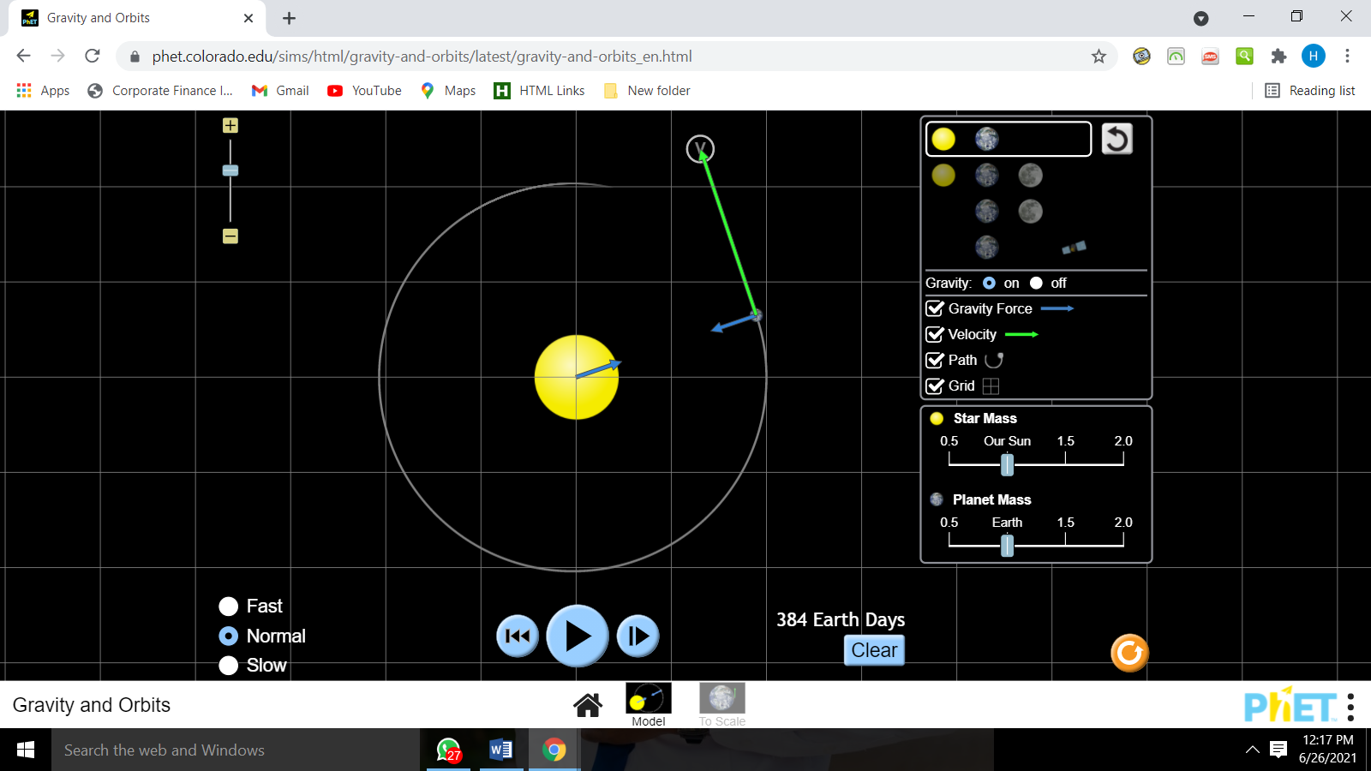

Turn ON gravity force button (green circle) above.
- What direction do the forces face? Screenshot this as proof:
The forces face towards the sun as well as towards the planet. Below is the screenshot.
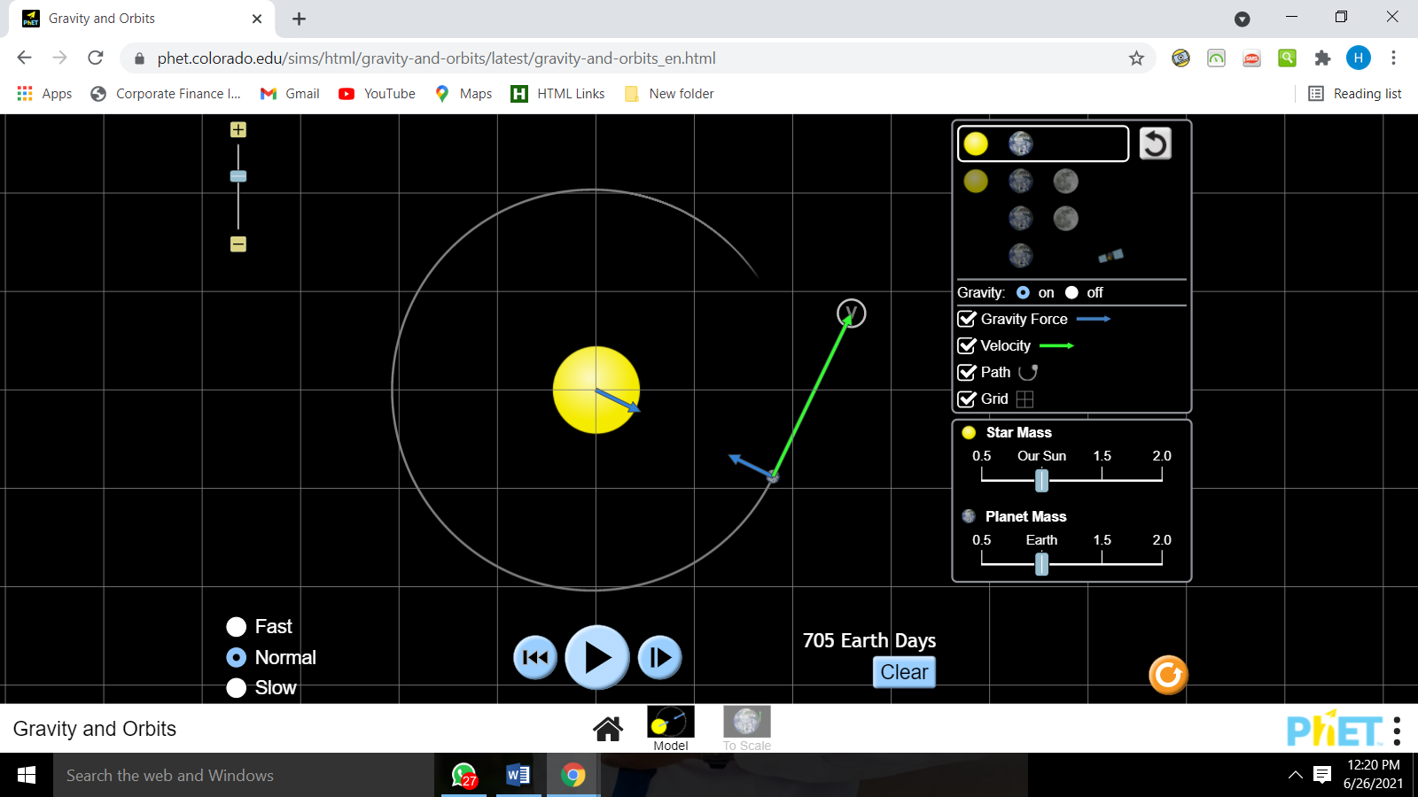

Turn the gravity OFF (green circle) above.
- What happens to the planet & why? Screenshot this as proof:
The planet does not circle the sun and instead moves away from the sun and out of the orbit. This is because the gravity forces are the forces that hold the planet onto its orbit. Below is the screenshot
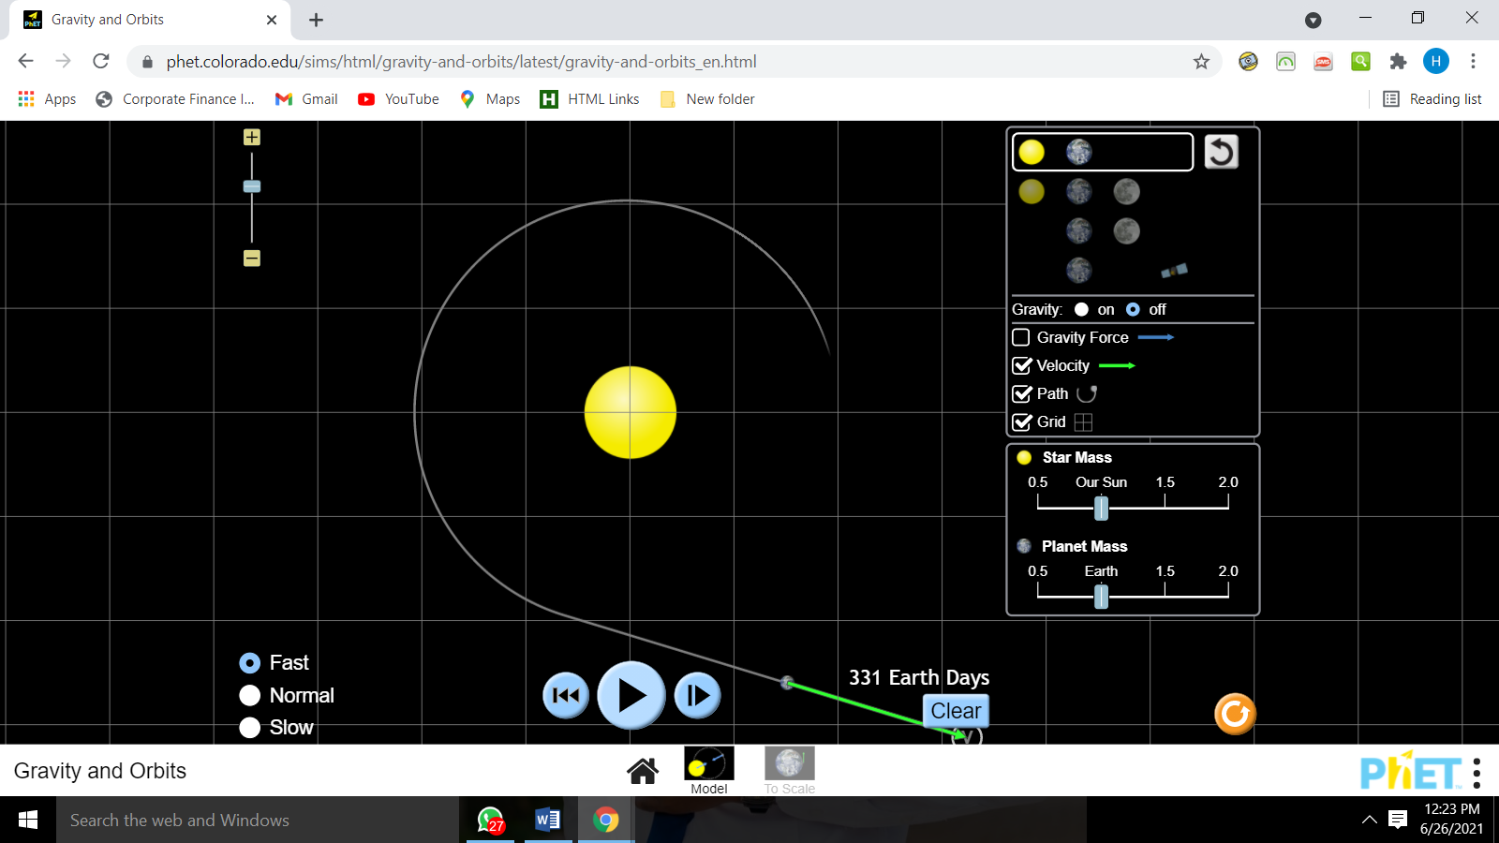
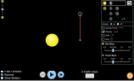

Now turn the gravity back ON and increase slightly the velocity of the plant by extending the red ‘v’ arrow of the planet, green circle.
- What happens to the planet in its orbit?
The planet goes out of its orbit.

- What is the shape of the orbit when the velocity is slightly increased?
The orbit deforms and forms a line as the planet moves away from the sun.

Now increase the velocity of the plant to a large extent by extending the red ‘v’ arrow.
- What happens to the planet in its orbit?
The planet still moves out of its orbit forming a straight line away from the sun.

Now decrease slightly the velocity of the plant by diminishing the red ‘v’ arrow, green circle.
- What happens to the planet in its orbit?
The planet moves out of its orbit towards the sun.

- What is the shape of the orbit when the velocity is slightly decreased?
The orbit is a line moving towards the sun.

Now decrease the velocity of the plant to a large extent by moving the ‘v’ arrow in.
The planet still moves towards the sun and out of its orbit

- Now try to explain this in terms of v and gravity: Compose at least one complete sentence.
For planets orbiting the Sun, this orbit causing force is the gravitational force. A planet orbiting a greater distance from the Sun doesn't move as fast as closer planets. There is a clear relationship between the gravitational force on a planet and its orbital speed. That relationship depends on the mass of the Sun.

- Is the velocity constant throughout the journey? Describe what you observe about the velocity?
The velocity is constant through out.
With the star and planet chosen and path/grid on, increase the size of the star by sliding the controller to 1.5/1.75/2.0, green circle.

- What do you notice about the orbit?
The orbit is not circular .

- What happens to the velocity on the path?
The velocity increases as the planet moves downwards and decreases as it moves upwards,

Now do the same but change the planet's mass 1.5/1.75/2.0 (blue circle).

- What do you notice about the orbit?
The orbit is circular.

- Why do you think is the reason behind the observation that you see in your previous answer?

This is because ,when the sun is increased in size,the gravity forces are increased hence the observation.

Part II: The Big E
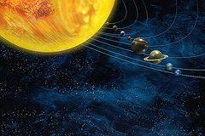

Kepler's three scientific laws describe the motion of planets around the Sun. In 1609, Kepler's laws challenged the long-accepted geocentric models of Aristotle and Ptolemy and followed the heliocentric theory of Nicolaus Copernicus by asserting that Earth orbited the Sun, proving that the planets' speeds varied and using elliptical orbits rather than circular orbits with epicycles. Most planet orbits are almost circles, so elliptical shapes are not obvious.
Calculations for the orbit of Mars first indicated to Kepler its elliptical shape, and he inferred that other heavenly bodies have elliptical orbits too.
“The big E” is the ellipse.

Simulations:

Elliptical Orbits & Kepler's 2nd Law: https://ophysics.com/f6.html

Kepler’s second law: https://www.walter-fendt.de/html5/phen/keplerlaw2_en.htm

Part II.A

Here are the directions for using a simulation to create the two ellipses.
Be sure you have watched the videos in Canvas!

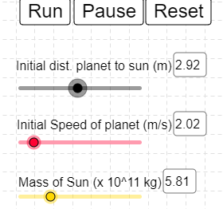
Go to: https://ophysics.com/f6.html

Click run, and observe what happens as the planet orbits the sun, on default settings.

Create two different orbits, by changing either the distance to the sun or the mass of the sun.

Make sure the orbit of the planet does not cross the sun.

Take a screenshot of your two orbits, and insert them into this doc.
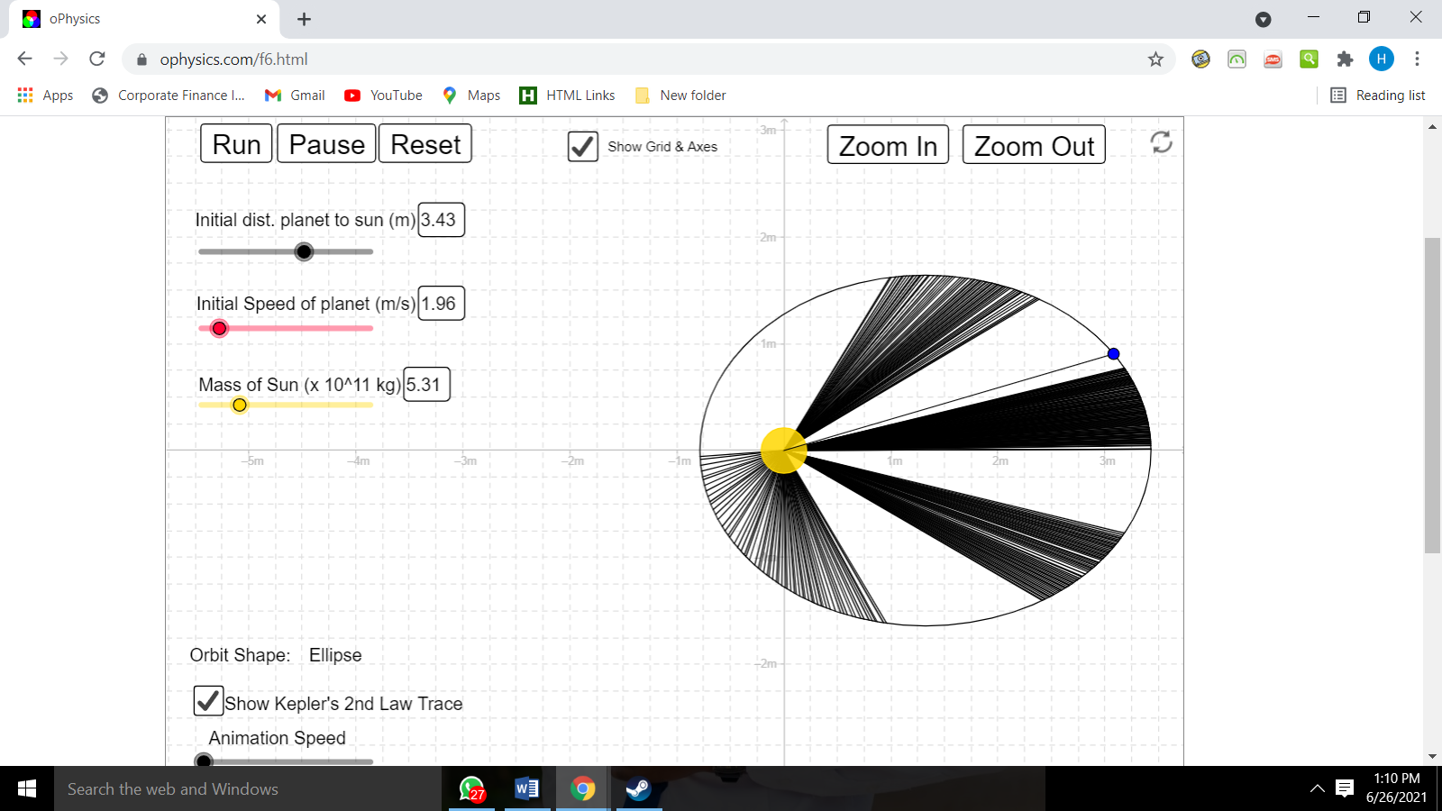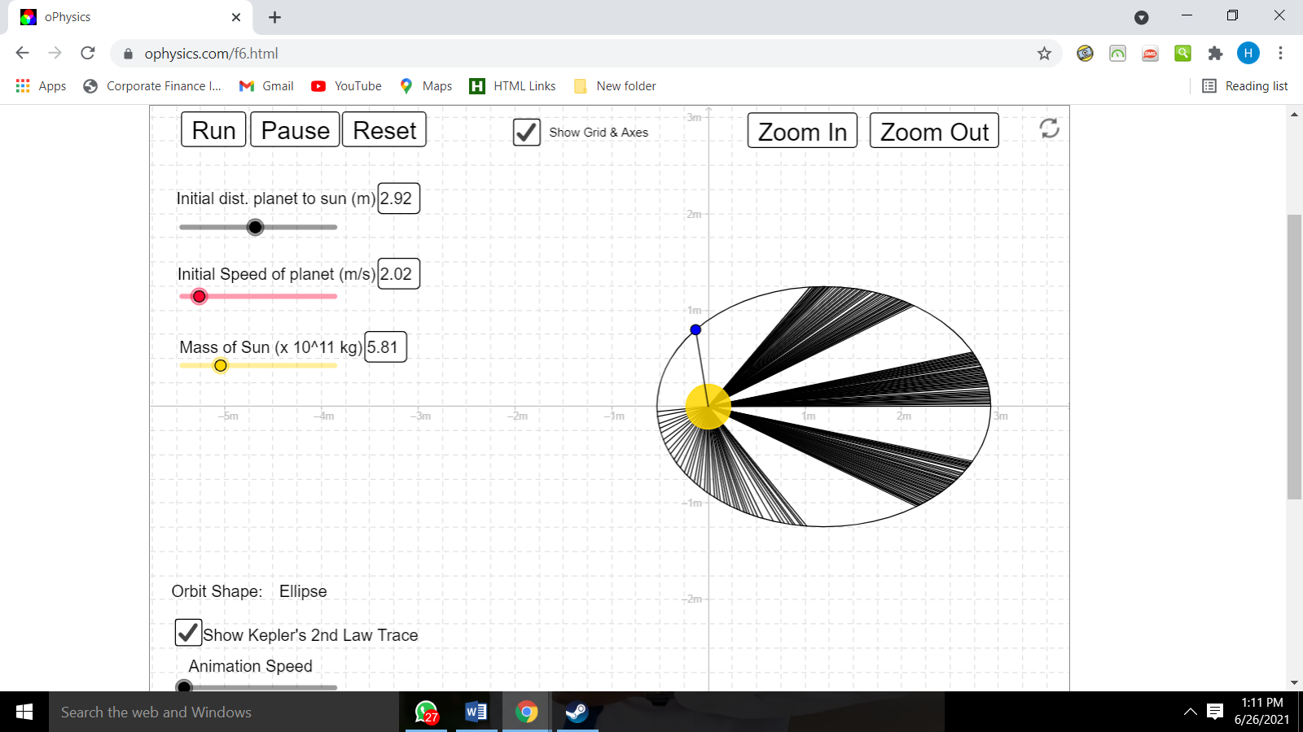

- Along the planet’s elliptical orbit, find the place where the planet is closest to the Sun. This is called the perihelion. Label this location P.

- Along the planet’s elliptical orbit, find the place where the planet is farthest from the Sun. This is called the aphelion. Label this location A.

- Draw a line from the perihelion to the Sun and label it q.

- Draw a line from the aphelion to the Sun and label it Q (this line will cross the entire ellipse).

- Insert a screenshot HERE of your simulated ellipses, with points added (you can do this in google drawings) . If needed, you can attach them as you turn in.

A
P

- Define the following based on the diagrams you have created.

Elliptical:
When an object moves around another object in an oval shaped path, it is known to be revolving in an elliptical orbit. All planets move in elliptical orbits around the sun. The Moon also moves around earth in an elliptical orbit.

Focus:
An orbital focus is one of two points on the major axis of an ellipse whose separation from the other focus determines the shape of an elliptical orbit. At one of the foci is the body being orbited

Foci:
The two foci lie on the major axis of the ellipse, at equal distances either side of its centre. In an elliptical orbit, one focus is occupied by the body being orbited; the other is referred to as the empty focus

Major axis:
the major axis of an ellipse is its longest diameter: a line segment that runs through the center and both foci, with ends at the widest points of the perimeter.

Semimajor axis:
one half of the major axis of an ellipse (such as that formed by the orbit of a planet)

Perihelion:
The position of closest approach, i.e. the shortest distance between the Sun and the planet

Aphelion:
the point in the orbit of a planet, comet, or other body most distant from the Sun

- How does your diagram model Kepler’s first law of planetary motion?
each planet's orbit about the Sun is an ellipse. The Sun's center is always located at one focus of the orbital ellipse. The Sun is at one focus. The planet follows the ellipse in its orbit, meaning that the planet to Sun distance is constantly changing as the planet goes around its orbit. My diagram shows all this.

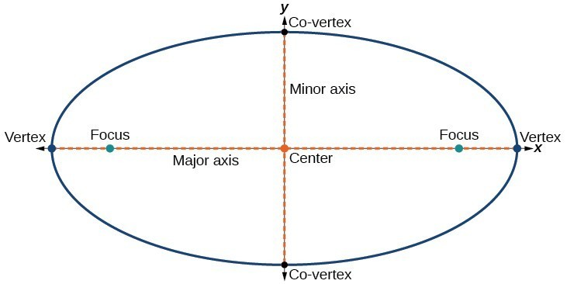

12.. Eccentricity is a measure of the deviation of an elliptical path from a perfect circle. In other words-how circular something is.

It is equal to the ratio of the distance between the foci (focuses) of the ellipse to the length of the major axis of the ellipse. By the way an ellipse is defined we can find these numbers from lengths of your two lines (q and Q). The distance between the foci is just the length of Q - the length of q. And the length of the major axis is the same as the length of Q + the length of q. So, if we label the difference of the lengths as f, and also label the sum of the lengths as d, then the eccentricity is:
e = f ÷ d.

Eccentricity ranges from zero (for a perfect circle) to values approaching one (for a very flattened ellipse).

Using your diagrams, fill in real data for your ellipses in the table below.

You will need to use a calculator in this part.

Ellipse Diagram | (q) Distance from Perihelion to the Sun m) | (Q)  Distance from Aphelion to the Sun (m) | Q – q = f | Q + q = d | (e) Eccentricity: f ÷ d  (Show Calculations)
1 | 1m | 2.5m | 1.5m | 3.5m | 1.5/3.5=0.43M
2 | 0.5m | 3m | 2.5m | 3.5m | 2.5/30.83M

Part II.B
Every planet in the solar system orbits the Sun in an elliptical path of varying degrees. Use the data for each object of the solar system and find the eccentricity (e = f ÷ d).
Object of the Solar System | (q) Distance from  Perihelion to the Sun (AU) | (Q)  Distance from Aphelion to the Sun (AU) | Q – q = f | Q + q = d | (e) Eccentricity: f ÷ d  (Show Calculations)
Mercury | 0.31 | 0.47 | 0.16 | 0.78 | 0.21
Venus | 0.72 | 0.73 | 0.01 | 1.45 | 0.007
Earth | 0.983 | 1.017 | 0.034 | 2 | 0.017
Mars | 1.38 | 1.67 | 0.29 | 3.05 | 0.095
Jupiter | 4.95 | 5.45 | 0.5 | 10.4 | 0.048
Saturn | 9.01 | 10.07 | 1.06 | 19.08 | 0.055
Uranus | 18.28 | 20.09 | 1.81 | 38.37 | 0.047
Neptune | 29.80 | 30.32 | 0.52 | 60.12 | 0.008
Pluto | 29.6 | 49.3 | 19.7 | 78.9 | 0.25
Ceres | 2.56 | 2.98 | 0.42 | 5.54 | 0.076
Halley’s Comet | 0.586 | 35.08 | 34.494 | 35.666 | 0.96
Vesta | 2.152 | 2.571 | 0.419 | 4.723 | 0.088

Check your values with this link: https://www.walter-fendt.de/html5/phen/keplerlaw2_en.htm

Questions:
- Compose a sentence about the relationship between a planet’s distance from the sun and the shape of its orbit.
The closer a planet is to the Sun, the stronger the Sun's gravitational pull on it, and the faster the planet moves. The farther it is from the Sun, the weaker the Sun's gravitational pull, and the slower it moves in its orbit.

- Looking at the data table of planetary orbits, do they all follow a pattern?
yes
  - What pattern would you expect to see?
Circular ones
  - What do you actually see?
Ones that are not fully circular

Part III: Kepler’s Laws
Objective: To review Kepler's three laws; to determine the properties of an ellipse; to relate these properties to the orbits of planets.

Note: This part of the lab consists of questions and calculations only. You don’t need to use any of the web-based simulations here.

Part 1: Kepler’s First Law
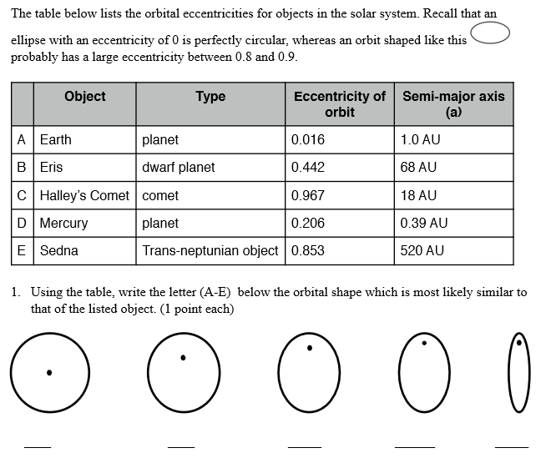
E,C,D,A,B
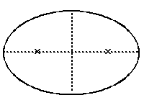
2. Eccentricity is a measure of the degree of “flattening” of the ellipse. Mathematically, the eccentricity of an ellipse is defined as the distance from a focus to the center of the ellipse divided by the length of the
semi-major axis.

To calculate the eccentricity, use this formula:
Calculated eccentricity:
_____________________________
Distance between foci
Length of major axis

Part II. Kepler’s Second and Third Law

Kepler's second law, which states that as a planet moves around its orbit it sweeps out equal areas in equal times, is often a difficult, totally confusing concept to picture, let alone understand. Since it is just a description, we are going to ignore it and state what the second law really means: that a planet travels faster when it is nearer to the Sun and slower when it is farther from the Sun.

- Examine the next figure of the "Planet D" orbiting the Sun “A” in a counterclockwise direction and fill in the blanks with the correct letter:
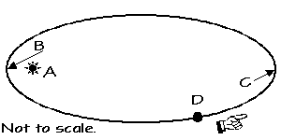
  - Focus __D____
  - Aphelion __C____
  - Perihelion ___B__
  - Increasing speed: __B__ to _A___
  - Decreasing speed: ___D_ to C____
  - Planet has greatest speed __A__
  - Planet has lowest speed __C____

- Now, state Kepler's Second Law in your own words and give your reasoning as to why planets "behave" this way:
Kepler's second law states that a planet moves in its ellipse so that the line between it and the Sun placed at a focus sweeps out equal areas in equal times.

Kepler's Third Law relates the period (P) it takes a planet to go around the Sun in an orbit of a given semi-major axis (a). Assume that the mass of the Sun is much, much greater than any of the planets (which it is), and measure P in years and a in astronomical units. The simplified relationship (formula) is:

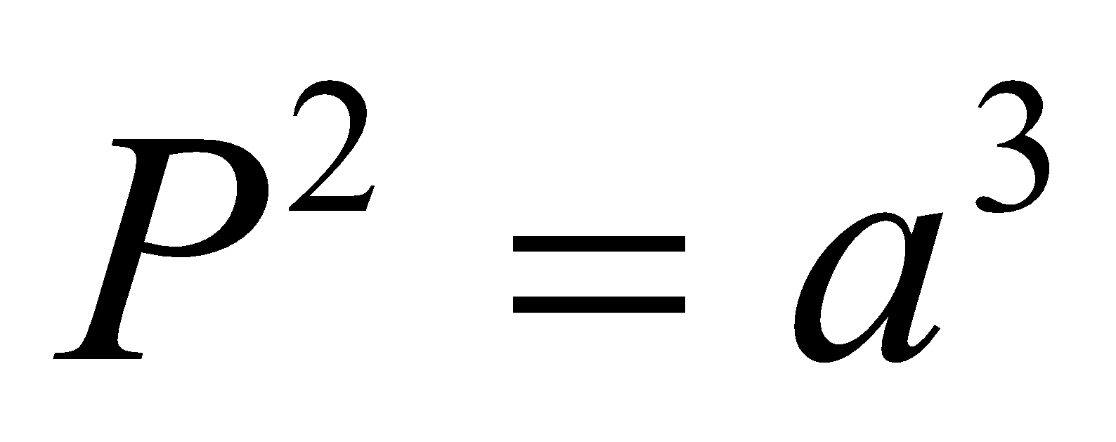

- The following two orbits have about the same value for a. How do their values of P compare?
The more circular one has a small P value

The oval one has a greater P

- Why is that? (think about what Kepler’s laws actually say)
________________This is because, the speed at which planets travel; a line connecting a planet to the sun will sweep out equal areas in equal times. " Kepler's second law means that a planet's orbital speed changes with its distance from the sun" ________________________________________________________________________

________________________________________________________________________________________

- Kepler's Third Law means that all orbits with the same semi-major axis have the same period. Explain how this can be when the orbits look so different, and why this makes sense.
. The ratio of the square of an object's orbital period with the cube of the semi-major axis of its orbit is the same for all objects orbiting the same primary. This captures the relationship between the distance of planets from the Sun, and their orbital periods.

Analysis Questions

- What is the maximum eccentricity that an ellipse can have? ____1_______ What is the shape of an ellipse with that eccentricity?___________straight line_______

- What is the minimum eccentricity that an ellipse can have? _____0______ What is the shape of an ellipse with that eccentricity?_____________a circle___________

- Why do you think the distance to a planet from the sun is given as an AVERAGE, rather than an exact distance?

The closer the planet was to the Sun, the faster it moved. Conversely, farther planets orbited the Sun more slowly. Knowing this, he was able to connect the average distance of a planet from the Sun with the time it takes that planet to orbit the Sun once.

- Imagine a space ship is orbiting the Earth with a constant orbital speed. Sketch the system below and add arrows to show the direction of the force on the spaceship at each of the points shown in the orbit below.

= Spaceship

E

- Assume the spaceship in the diagram is an alien ship with a deflector screen which can make it immune to gravity. If the ship is traveling along in its orbit and it turns off its engines at the exact same time as it turns on its gravity deflector shield, what will happen? Choose one answer and defend it.

- The ship will continue traveling in a circle.
- The ship will slowly drift outward from the orbit.
- The ship will travel straight out perpendicularly from the circular orbit.

- The ship will spiral down to the Earth.
- The ship will come to a full stop, hovering above the Earth

.
- The ship will come to a full stop, hovering above the Earth

This is because there are no forces of gravity pulling it towards the earth.

